Decoding Lab
Student ID _____________________
Student Name _____________________
Start Time ________________________
Finish Time ________________________

Understanding a Secret Message, find key1-4 and get the right message.
Carefully follow the instruction (decode_lab_instruction.pdf) and write down the answer of questions in the instruction.

3.1 Address of data is: __0x7ff699b0a0a0___

3.2 Write down the first 40 characters of data:
__cccccccccFFrromo: mFr:ie ndC·TTo:E Y·ouT __

4.1 Start: ___9_____ Stride: ______3________

4.2 [fill in the blanks]
the address of dummy：0xd44d1ff854
address of key1：0xd44d1ff850
address of key2：0xd44d1ff84c

4.3 [fill in the blanks]
key1:1
key2:777

（此处使用vs查看反汇编）
5.1 [fill in the blanks]
Return address of process_key34: 0x00007FF6C0011E7C

5.2 [stack frame]
the stack frame of process_key34:
0x00000023c34ff3d0：rsp
0x00000023c34ff3f0：rbp
return_addr
key3
key4

5.3 [Answer the question]
Return address after process_key34：0x00007FF6C0011EAF

5.4 key3: ________-1___________

5.5 key4: ________51(VS x64)_______

5.6 [screen shot]
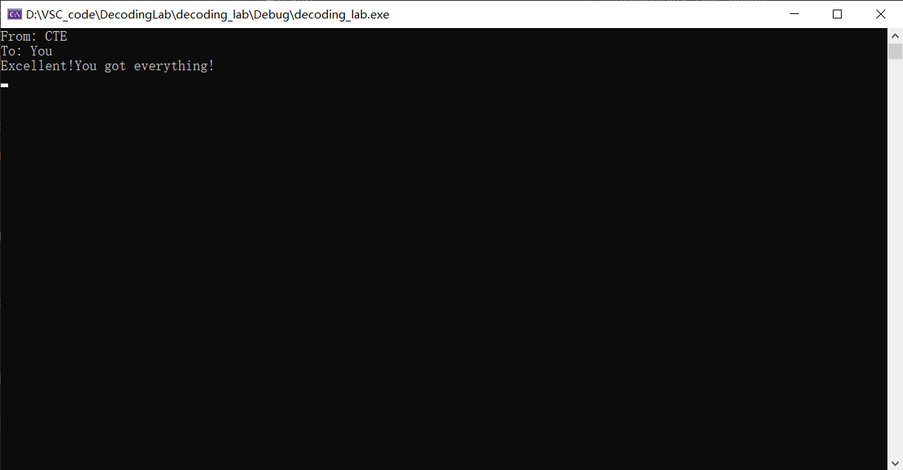

//若函数process_keys34的操作为*(((int64_t *)&key3) + *key3) += *key4，则key4=51（使用x64架构）；若为*(((int *)&key3) + *key3) += *key4，则key4=45（使用x86架构）

//怀疑舒莉发的程序有问题，应该就是*(((int *)&key3) + *key3) += *key4的😤

//参考资料：https://blog.csdn.net/weixin_55196798/article/details/121141728
